CURRICULUM VITAE  Pr Roch Domerego􏰀 | 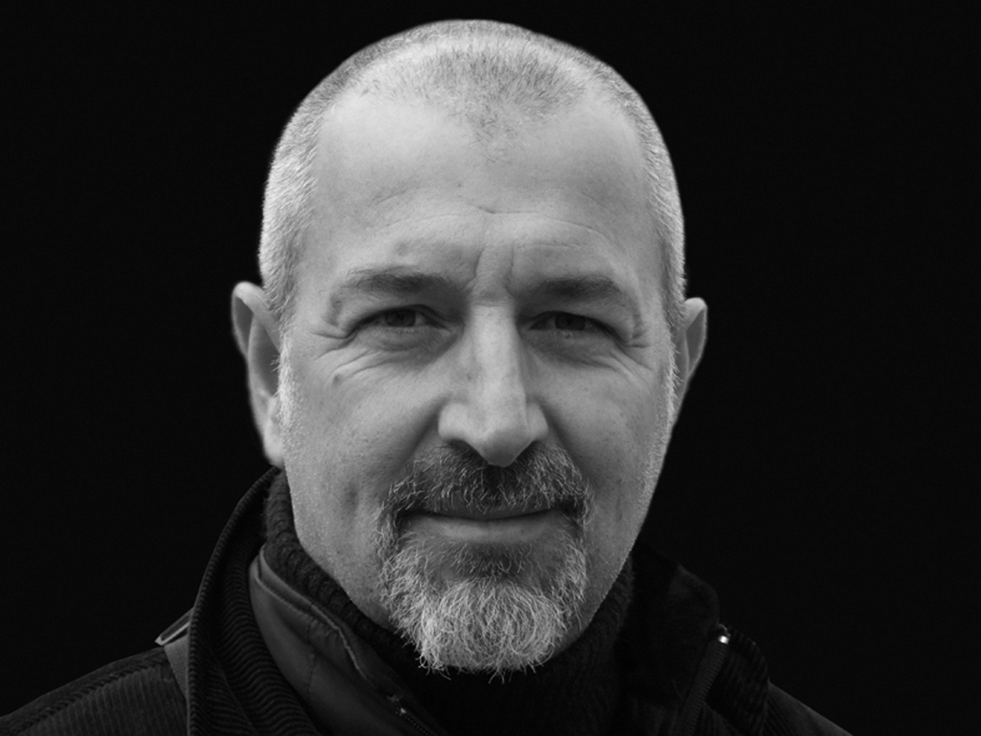

Name: Domerego
First name: Roch
Date of birth: 21 November 1958 in Montpellier (France)
Nationality: French

Background:

- Agricultural biologist bachelor,
- Expert in Bees and Beekeeping (UNDP and EU).
- Permanent Invited Professor at the Medical University of Calixto Garcia,
La Havana, Cuba since 2003.

Languages:

French, English and basic Spanish

Responsibilities:

- President of the European Live Beekeeping Association (ELBA) since 1995.
- Manager of Baroch Editions since 2010.
- Author or co-author of 12 scientific, historic and photographic books on bees’ life.
- Consultant appointed by the European Commission for feasibility studies for bees’ selection and honey traceability in Chile in July 2011.
- Managing Director of an International Laboratory: Api-Ar Int. - Brussels (1999 - 2010).
- Consultant appointed by the Greek Dodecanese administrative area for feasibility studies on honey traceability (2008).
- Clinical research supervisor on Apitherapy treatment of multiresistant bacteria in polyclinic Finlay Institute, in Calixto Garcia University Hospital, La Havana and in Frank País University Hospital, La Havana (from 1998 to 2006).
- Consultant appointed by UNDP for feasibility studies in Burkina Faso, follow-up and evaluation, comprehensive management plans for African beekeeping development, introduction of beekeeping into multi-disciplinary projects for rural development, transformation of natural products in pharmaceuticals products (2003-2005).
- Consultant to UNDP for project studies in Cameroun in 2005.
- Vice-President of the Apitherapy Standing Commission, Apimondia (International Confederation of Apicultural Organizations) – Rome (1997-2012).
- Co-organizer of Symposia and Congress in La Havana (2002, 2003, 2004, 2005).
- Assistant to Pr. Descottes in CHU of Limoges (France) on healing activity of honey (1994-1997).
- Writer of the scientific Good Manufacturing Practice (GPM) charter on bee products for medical practice (1994).
- Manager of SOGEPAR Co in Guinea (Conakry) (1984-1986).
- Implantation Equipment Project Manager of the Damas Blood Transfusion Center in FRANCOMI (French company) (1983-1984).
- General Manager in a Rwandan beekeeping project with African bees (French cooperation (1980-1981).

Publications, courses and conferences:
Publication of 13 books
Published book as author:
Ces abeilles qui nous guérissent, Ed. JC Lattès, 2001 and new version in 2012 (published in French and English)
Melipona, l’abeille sacrée des Mayas, Ed. Baroch Editions, 2011 (published in French and Spanish)
La thérapie au venin d'abeille, Ed. Baroch Editions, 2012
Miel et miellats, regard critique sur les étalages, Ed. Baroch Editions, 2013
Le miel de l'alliance sacrée, (roman) Ed. Baroch Editions, 2015
Le regime protein vegetarian, Ed. Baroch Editions, 2017
Published book as co-author:
Le traité Rustica de l’Apiculture, Ed. Rustica, 2002
L’apithérapie, Ed. Amyris, 2003 (published in French, Spanish, Italian)
Les remèdes de la ruche, Ed. Alpen, 2006
La reine africaine (roman), Ed. JC Lattès, 2008 (published in French and German)
Melipona the Mayan Princess, Ed. Baroch Editions, 2014 (comic book scriptwriter, published in Spanish, English, French)
La médecine des abeilles, Ed. Baroch Editions, 2016
Guide pratique de la médecine des abeilles, Ed. Baroch Editions, 2016

Publication of many articles and participation to various lectures and conferences in several countries: Japan, Burkina Faso, Cameroun, South Africa, France, Belgium, Switzerland, Greece, Cuba, USA, Canada, Chile, Australia…

Professor for several international master classes in universities: Cuba, Japan, Africa, Mexico and Europe.
Participation in various congress and symposia as a scientific modulator and speaker.
Board of Examiners for the Thesis on the antibacterial activity of honey in Burkina Faso.

Misc.
Participation in various international exhibitions as photographer.
Awarded at the photographic international meeting, Tunisia, 2005.
Awarded at the photographic national meeting in Roquebrune-sur-Argens, France, 2012.

